**GENETICS**

Genetics is the scientific study of heredity and variation among organisms. It is the branch of science that accounts for the occurrence of similarities and differences among organisms of the same species; as well as explaining how traits are transmitted to off springs from their parents.

**Inheritance** refers to the process by which characters/traits are passed from parents to off springs.

## The importance of genetics

* It is applied in genetic engineering to produce better breeds and varieties of plants and animals by altering their genetic constitution.
* It is important in courts of law to determine the paternity of the child.
* Genetics forms the basis of blood transfusion to determine compatible blood groups.
* Genetic counselling is important in preventing transmission of genetically determined diseases among married couples. This will help to relieve the families and community of the costs on treatment as well as the suffering of the sick and their families.
* It can be used in identification of criminals by use of finger prints and DNA profiling.
* It is used in molecular biology to manufacture artificial enzymes, hormones and vaccines by manipulating responsive genes from organisms.
* Forms the basis of cloning to increase the number of genetically important plants and animals

**DEFINITION OF TERMS USED IN GENETICS**

**Gene;** A gene is the basic unit of inheritance that determines the organisms’ characteristics. All the characteristic features of an organism are defined at fertilization by the genes inherited from parents but can be greatly modified by the environment in which the organism lives.

**Alleles**; Are alternative forms of the same gene.

Most of the genes occur in two alternative forms called alleles one of which is dominant and the other recessive both of which are represented by alphabetical letters just for study purposes

**Dominant gene/allele;** Is a gene/allele whose trait is expressed phenotypically even in presence of a different allele. Such genes are always represented by capital letters when performing a genetic cross.

**Recessive gene/allele;** is a gene/allele whose character is not expressed phenotypically in presence of a different allele but is only expressed in a homozygous recessive state. Recessive genes are always represented by small alphabetical letters in a genetic cross

* + Consider the gene controlling height in garden peas, the allele **T** for tallness is dominant over the allele **t** for shortness. A plant with dominant genes **(TT)** is tall and the one with recessive genes **(tt)** is short while a plant with one of each genes **(Tt)** is also tall

**Genotype;** is the genetic makeup/constitution of an organism as inherited from the parents. It is determined at fertilization and does not depend on the environment.

An organism with similar copies of alleles for a given gene is said to have a **homozygous genotype** e.g. TT, AA, rr etc. while an organism with different copies of alleles for a given gene is said to have a **heterozygous genotype.** E.g. Tt, Aa, Rr etc

**Phenotype;** Refers to the physical/outward appearance of an organism as determine by the interaction between its genotype and the environment in which it lives.

A pea plant which is homozygous tall (represented as TT) but growing on nutrient-poor soils will become stunted and appear short. Such a plant is genotypically tall but the environment in which it grows modified it into a phenotypically short/dwarf plant.

**Locus** (plural loci). This is the position on the chromosome where the genes are located.

**Homozygous;** this is a condition where an individual possess identical alleles for a particular gene e.g. TT, tt, AA.**OR** is when the alleles found at a given locus are identical

**Heterozygous;** this is a condition where an individual possess non-identical alleles for a particular gene e.g. Tt, Bb OR is when the alleles at a given locus are different

**Pure breeding (true breeding)**, this is where the individuals being crossed are homozygous **Crossing(X)**. This refers to the mating of the male and female organisms under a consideration.

**First filial generation (F1)**; this refers to the set of offsprings obtained from crossing two pure breeding parents with contrasting characteristics. These individuals are therefore heterozygous hybrids

**Second filial generation (F2)**; this refers to the set of off springs that are obtained from crossing mature F1hybrids.

**Selfing:** This refers to the crossing of offsprings of the same parents.

**Test cross** is a cross between an organism with an unknown genotype with a homozygous recessive organism so as to determine the unknown genotype.

This is because phenotypically dominant organisms may ether be homozygous or heterozygous. In such a cross if all hybrids show the dominant trait then the unknown is homozygous dominant. A heterozygous individual will result into a mixture of hybrids in a ratio of 1:1 of dominant to recessive trait.

**Back cross**. This is the mating of an offspring with one of its parent so as to prove the genotype of the parents.

**Reciprocal cross;** this is a cross in which the genotypes of the parents have been reversed

## MENDEL’S GENETIC EXPERIMENTS AND MONOHYBRID INHERITANCE

**Monohybrid inheritance** refers to the inheritance of a single pair of contrasting characteristics. Examples include, inheritance of height, blood groups, albinism, sickle cell anaemia, and sex linked characteristics etc.

This mechanism of inheritance was discovered by an Austrian monk and biologist Gregor Johann Mendel who carried out a number of genetic experiments using the garden pea plants *(Pisum sativum);* which he grew in the vegetable garden in his monastery. He later observed many sexually reproducing organisms and found out that they had variations among themselves despite being of the same species.

### Why Mendel used garden peas

* + They occurred in many varieties with distinct characters
  + The plants were easy to cultivate
  + All their offsprings were fertile
  + They have a short life cycle that they reproduced so quickly
  + The plants also had many contrasting characters with no intermediates
  + Their reproductive structure were enclosed in petals which allowed for production of pure breeding plants due to self-pollination over many generations

**MENDEL’S EXPERIMENTS**

In one of his experiments, Mendel crossed tall pea plants with dwarf pea plants. In order to properly manage the cross, Mendel covered the stigma of all flowers of one group, and removed all the anthers from the flowers of

another group of pea plants in order to prevent self-pollination, and transferred pollen using a brush. The resultant seeds were planted and he observed that all the F1off springs were tall.

He then selfed the F1 pea plants to get F2. This generation comprised of a mixture of tall and short pea plants in a ratio of 3 tall: 1short plants.

**NB:** The **3:1** ratio is known as Mendel’s monohybrid ratio of the dominant and recessive characters respectively in the F2 generation.

### Observation;

Mendel was able to observe that neither of the F1 nor F2 had intermediate phenotypes.

### Conclusion;

He then concluded that inheritance is **not** the mixing/blending of features to produce intermediates but rather the process by which **internal factors** of the body **may or may not** express themselves in the phenotype.

From his conclusions, Mendel was able to formulate his first law of inheritance which is well known as the law of monohybrid inheritance/law of segregation/law of particulate inheritance

### LAW1 states that “The characteristics of an organism are controlled by internal factors which occur in pairs but only one can be carried in a single gamete”.

Later with advancements in technology and microscopy, internal factors later came to be known as **genes** and Mendel’s first law was modified. It can **modernly** be stated as follows. “The characteristics of a diploid organism are controlled by alleles which occur in pairs but singly in gametes”.

**Meiosis explains:**

Mendel’s first law can currently be explained/accounted for in terms of meiosis. The genes which determine organisms’ characters usually occur in two alternative forms called alleles located on homologous chromosome. During anaphase 1 of meiosis, these homologous chromosomes separate (segregate) and move to opposite daughter nuclei. Subsequent cell division results into two gamete cells each containing one of the two alleles; therefore the alleles occur as pairs in body cells but singly in gamete cells.

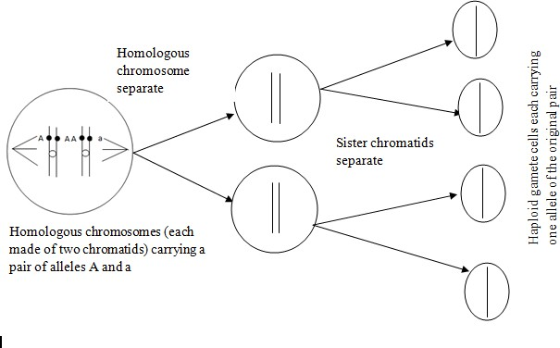***Illustration:***

## A full genetic explanation of Mendel’s first law and the 3:1 ratio

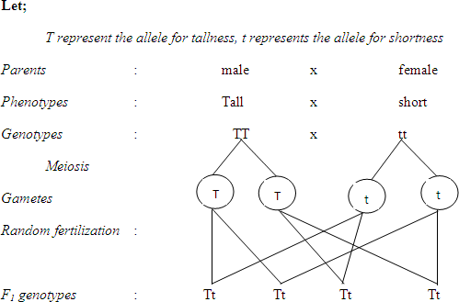

Genotypic ratio : All Tt

Phenotypic ratio : All tall

To obtain F2 generation, F1 hybrids were selfed as shown below

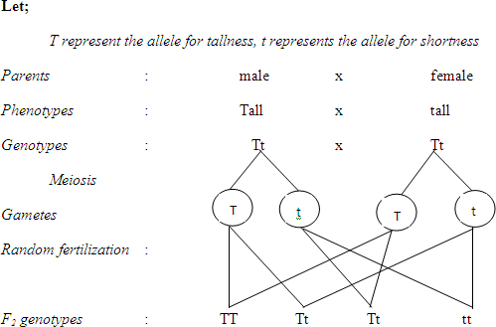Genotypic ratios: 1TT : 2Tt : 1tt; Phenotypic ratios: 3tall : 1 Short

Mendel carried out many other experiments on peas and other organisms and all gave consistent results as shown below:

**NB:** It became so obvious to predict which trait of a given pair is dominant over the other. In a cross starting with pure breeding parental stocks, all the F1 hybrids show the dominant trait. In addition, a larger proportion of the F2 hybrids show the dominant trait while those showing the recessive one are always fewer

## WORKED EXAMPLES

1. In a garden pea plant there are two forms of heights. When a pure breeding tall pea plant was crossed with a short pea plant all the offsprings obtained where tall when the offsprings were selfed a phenotype ration was obtained in F2.
   1. Using suitable genetic symbols, workout the genotypes and phenotypes of the F2 generation
   2. What are the phenotypic and genotypic ratios of the F2 generation
   3. Explain how you would determine the genotype of F1 tall pea plants formed
   4. Suppose 700 pea plants where produced in the F2 generation
      1. How many were tall?
      2. How many were short?
2. Suppose a man who is a tongue roller marries a woman who is a non-tongue roller and all the children obtained in F1 are tongue rollers.
3. Work out the phenotypic and genotypic ratio as obtained in F2 generation.
4. What is the probability that the 4th born is a non-tongue roller?

## Note; for any genetic cross:

* Appropriate letters are ‘let’ to represent respective alleles involved
* A cross**(X)** must be indicated to symbolize mating between the parents
* Directive words must be indicated to define each step of the cross
* In case of identical gametes, only one can be indicated

## Solutions (a)

F1 phenotypes: all tongue rollers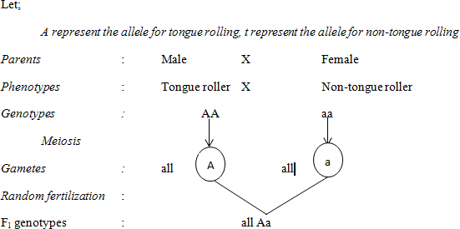

By selfing the F1 hybrids to obtain F2

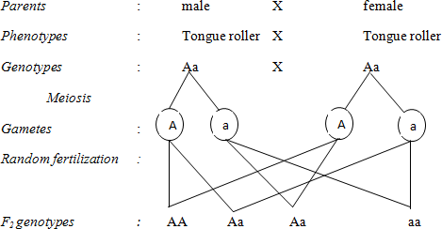

Genotypic ratios: 1AA: 2Aa: 1aa; phenotypic ratios: 3tongue rollers: 1non-roller

1. Probability that the 4th born is a non-tongue roller

= 1x 1 x 1x 1 = 1

4 4 4 4 256

## NB:

* The such crosses can be performed in terms of probability as follows

Each gamete carrying any of the two alleles has 0.5 chance of fusing with the gamete from the other parent,

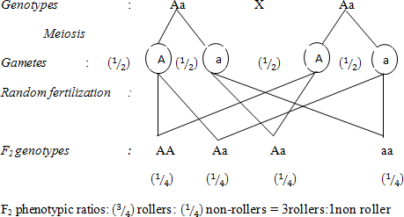

In case of individuals showing the dominant trait, the genotype may either be homozygous dominant or heterozygous. Such genotypes can be determined by performing **a test cross;** that is, crossing the unknown with a homozygous recessive individual. If the unknown is homozygous, the resultant hybrids will all show the dominant trait but otherwise, a mixture of dominant and recessive traits are produced in a ratio of 1:1

In a test cross, a homozygous dominant individual cannot be used because in such a case; regardless of the unknown genotype, all the resultant hybrids would show the dominant trait

## EXAMPLES OF MONOHYBRID INHERITANCE IN MAN

There are many genetically determined abnormalities and diseases that affect man (and other animals). Since these are genetic diseases, they can only be inherited from parents and their occurrence is determined by those genes inherited from parents during fertilization

## Examples of such diseases include:

* Sickle-cell anaemia
* Albinism
* Achondroplasia
* Cystic fibrosis and many more

**NB:** Research has showed that most of, though not all the genetic abnormalities are caused by recessive genes (alleles) and the genes responsible for normal conditions are dominant. This implies that for an individual to suffer from such diseases, they must have two copies of the responsive genes (homozygous recessive). The heterozygotes and the homozygous dominant individuals are normal. Though the former are phenotypically normal but their cells contain a copy of the recessive allele and are described as carriers

## INHERITANCE OF SICKLE-CELL ANAEMIA

Sickle-cell anaemia is a recessive character caused by a point substitution mutation in which glutamic acid in normal haemoglobin is replaced by valine. Normal haemoglobin **(HbA)** contains an amino acid glutamic acid at position 6 of the -chain. The amino acid is **polar and hydrophilic** which make normal haemoglobin soluble in water. It is coded for by the DNA triplet CTT and its complementary mRNA codon is GAA. A substitution mutation leads to replacement of T with A making the DNA triplet CAT and its complementary mRNA codon GUA. This tiplet codes for valine which is non-polar and hydrophobic hence reduces the solubility of haemoglobin especially at low oxygen tensions. This abnormal haemoglobin crystallizes into rigid rod-like fibres which distort the normal biconcave shape of RBCs into a crescent/sickle shape. Such abnormal haemoglobin is called **HbS,** It has a very low oxygen- carrying capacity leading to symptoms of anaemia and the disease is known as **sickle-cell anaemia.**

Being a recessive character, for a person to be a sufferer they must possess two copies of the faulty gene (homozygous recessive, i.e. HbSHbS or ss). Heterozygotes (carriers, i.e. HbAHbS or Ss) have one copy of the responsive gene whose effects are masked by the other dominant gene. They don’t suffer from the disease symptoms except at exceptionally low oxygen tensions; this is known as **sickle-cell trait**.

It is therefore advisable to avoid exposure of such people to low oxygen environments like crowded places, high altitudes and flying in unpressurised aircrafts.

**Question;** if two people suffering from sickle cell trait are married, what is the probability that they will produce an anaemic child?

## Solution

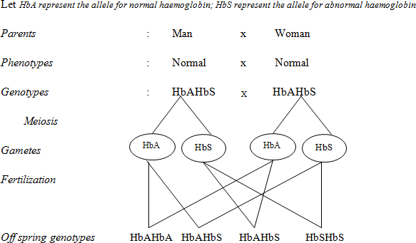

Genotypic ratios: 1HbAHbA:2HbAHbS:1HbSHbS

Phenotypic ratios: 1normal:2 carriers: 1sickler

Probability of a sickler is 1⁄4 = 0.25

## Complications due to sickle cell anaemia

1. Anaemia occurs because the sickle cells are destroyed which lowers the amount of oxygen to be carried leading to acute anaemia. This leads to;
   * Fatigue (weakness)
   * Poor physical development
   * Dilation of the heart which may lead to heart failure
2. Interference with circulation of blood because sickle cells get jammed in tiny capillaries and small arteries. This leads to;
   * Heart damage which leads to heart failure
   * Lung damage which leads to pneumonia
   * Kidney damage which leads to kidney failure
   * Liver damage
3. Enlargement of the spleen because the sickle cells collect in the spleen for destruction

The effects above make the homozygous sufferers to often die before reproductive age.

**NB:** Despite the above complications suffered by sufferers of sickle cell anaemia, the heterozygotes tend to have an advantage of showing increased resistance to the plasmodium parasite that causes malaria much more than both the sufferers and the normal. This resistance is as a result of two factors:

* The consistent change in oxygen levels between normal and sickle cells makes it difficult for the parasite to adapt. In such cases, the immune system of the body eliminates the parasites before the disease is established rendering resistance to the heterozygotes

This is referred to as the **heterozygous advantage** which increases chances of survival for heterozygotes especially in the tropics where malaria is one of the leading causes of death

## INHERITANCE OF ALBINISM

Albinism is a recessive character which results into failure of formation of body pigments.

Albinos have the following characteristics as a result;

* Light-coloured skin
* White hair
* Pink eyes

**SQ;** Man with normal skin marries a carrier for albino skin. What is the probability that some of their children will be albinos?

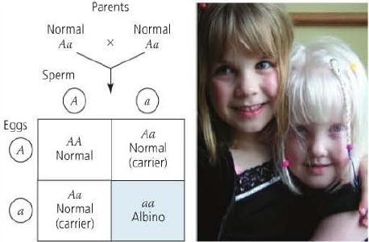What is the probability that the sister with normal colour is a carrier?

## INHERITANCE OF CYSTIC FIBROSIS

This is a recessive character caused by a mutation resulting into accumulation of abnormally **thick and sticky mucus** that blocks the pancreatic duct, bile duct and air passages.

The mutation occurs on an autosomal chromosome 7 affecting the gene that codes for **a chloride channel protein** in epithelial cells. This results into total absence or malfunctioning of this channel protein hence interfering with chloride ion flow. Chloride ions accumulate in the cells and attract sodium ions towards the opposite charge; this increases the ion concentration, hence osmotic potential of the cells which prevents **osmotic outflow** of water. As a result, the mucus secreted is dry, thick and sticky; blocking small tracts of some body organs. This is known as cystic fibrosis.

In the pancreas, fibrous patches called cysts develop (hence the name) and complications include digestive problems due to poor release of pancreatic enzymes, poor absorption of digestive products, chronic lung diseases, reduced fertility etc.

## ACHONDROPLASIA (DWARFISM)

Although many harmful alleles are recessive, a number of human disorders are due to dominant alleles. One example is *achondroplasia,* a form of dwarfism that occurs in one of every 25,000 people in the world. Heterozygous individuals therefore have the dwarf phenotype as shown below.

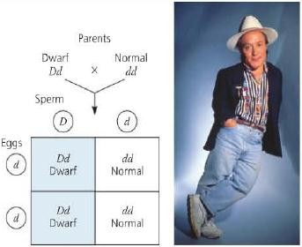

a

Since this character is dominant (caused by a dominant allele), all people who are not achondroplastic -99.99% of the population are homozygous for the recessive allele. Like the presence of extra fingers or toes mentioned earlier, achondroplasia is a trait for which the recessive allele is much more prevalent than the corresponding dominant allele.

# DIHYBRID INHERITANCE AND MENDEL’S SECOND LAW OF INHERITANCE

Dihybrid inheritance refers to the inheritance of two pairs of contrasting characteristics simultaneously.

For instance, in one of his experiments; Mendel crossed pure breeding **tall** pea plants with **red** flowers with pure breeding **dwarf** plants having **white** flowers. All in the F1 progeny were **tall with red flowers**. This showed just like Mendel had discovered before that the alleles for tallness and red flowers were dominant to those for dwarfness and white flowers respectively.

Mendel went ahead to self-pollinate the F1 plants and obtained an F2 progeny, this comprised of a variety of phenotypes as summerised in the table below.

* 315 Tall with red flowers
* 101 Tall with white flowers
* 108 Dwarf with red flowers
* 32 Dwarf with white flowers

These give the respective phenotypic ratios as 9:3:3:1. This is known as **Mendel’s Dihybrid ratio**; the ratio of phenotypes in the F2 generation for a Dihybrid cross.

From this and many other similar crosses, Mendel was able to make the following observations:

* Both phenotypes/characters (height and flower colour) combined in the F1 but separated and behaved independently in the F2.
* Two of the F2 phenotypes resembled one or the other of the parental phenotypes WHILE two new combinations of phenotypes appeared in the F2; (Tall/white and Dwarf/red). These are known as recombinants.
* The allelomorphic pairs of characteristics (controlled b different alleles of the same gene) occurred in a phenotypic ratio of 3 dominant: 1 recessive.

E.g. 3tall: 1 dwarf and 3red: 1 white.

Basing on these observations, Mendel formulated his second law known as the law of independent assortment. The law states that; **“**Any **one of a single pair of characters may combine randomly with either one from another pair”**

Below is a full genetic explanation of the 9:3:3:1 ratio of phenotypes in the F2 generatioon of a dihybrid cross.

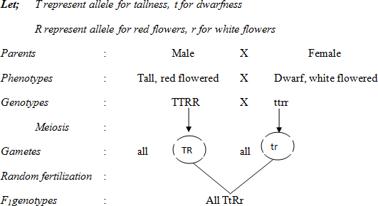

Phenotypic ratios : All Tall with red flowers.

By selfing F1 plants;

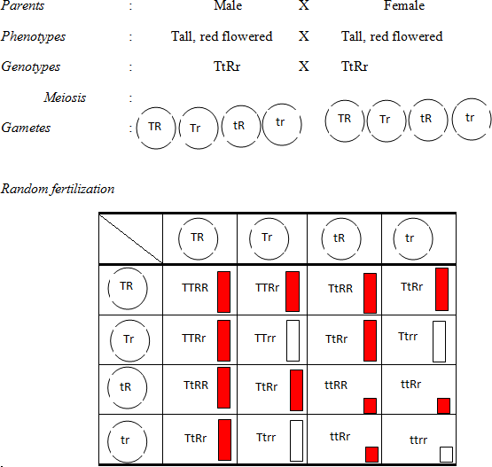

## NB: When performing a dihybrid cross;

* Alleles of the same gene cannot pass into the same gamete (they segregate during meiosis). I.e. T can only be present with Y or y but not t while t can only be present withy or y but not T as in the above case
* The possible combination of gametes during fertilization is shown in a Punnett square (after the Cambridge geneticist R. C. Punnett). This minimizes errors when listing the combinations.

In summary; the following can be noted from Mendel’s hypotheses:

* + Each characteristic of an organism is controlled by a pair of alleles.
  + During meiosis, each pair of alleles segregate (separates) and each gamete receives one of each pair. This is known as the law of segregation.
  + During gamete formation, either one of a pair of alleles can pass into the same gamete with either one from another pair. This is known as the law of independent assortment.
  + Each allele is transmitted one generation to the next as a discrete unit
  + Each diploid organism inherits one allele for each character from each of the two parents.
  + If an organism has two unlike alleles for a given gene, one may be expressed (dominant) at total exclusion of the other (recessive).

## MEIOSIS EXPLAINS:

Mendel’s second law can be explained/accounted for on the chromosomal basis by meiosis.

During formation of gametes by meiosis, the distribution of each allele from a single pair is entirely independent of alleles from other pairs. This in turn depends on the random orientation of homologous chromosomes onto the equatorial spindle in metaphase I. Subsequent separation during anaphase I leads to a variety of allele combinations in gametes. In this process; any one of a single pair of alleles can combine randomly with either one form another pair.

### Illustrations:

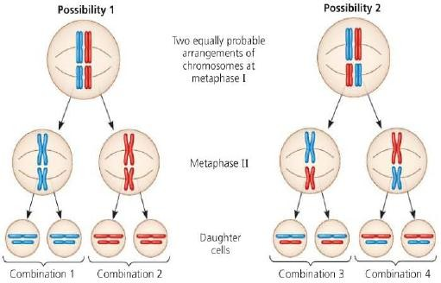

**NB:** For the haploid number of chromosomes = n, the total number of possible combinations in gametes is given by 2n

## WORKED EXAMPLES:

1. When a pure breeding broad and long winged female fly was crossed with a narrow and vestigial winged male fly all the F1 offsprings obtained head broad abdomen and long wings.

1. Using suitable genetic symbols work out the phenotypes and genotypes that were obtained in F2 generation.
2. Suppose 480 flies were obtained in F2 work out the numbers of the flies for each phenotype class.
3. How many of these flies were recombinants.

Solutions:

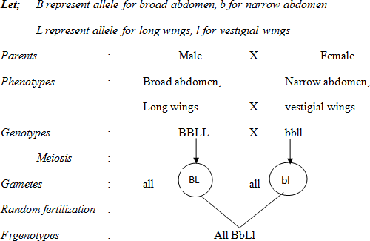

Obtaining F2

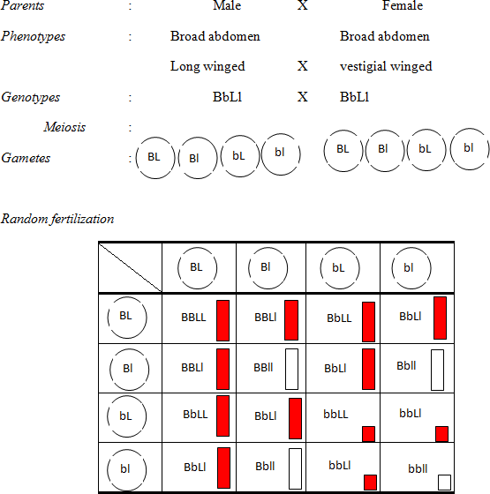

1. Phenotypic ratios = 9:3:3:1, Total ratio = (9+3+3+1) = 16 Number of flies = (𝑅𝑎𝑡𝑖𝑜) 𝑥480 Flies

𝑇𝑜𝑡𝑎𝑙

* 1. Broad abdomen, long winged =
  2. Broad abdomen, vestigial winged
  3. Narrow abdomen, long winged =
  4. Narrow abdomen, vestigial winged

1. Number of recombinants = (90 + 90) flies = 180 flies

## SAMPLE QUESTIONS:

1. In guinea pigs, there are two alleles for hair colour and two for hair length. In a breeding experiment, all the F1phenotypes produced from a cross between pure breeding short black-haired and long white-haired parents had short black hair. Explain
   1. Which alleles are dominant
   2. The expected F2 phenotypes
2. Flower in sweet pea plants is determined by two allelomorphic pairs of genes (R,r and S,s). Presence of at least one dominant gene from each pair makes the flowers purple while all other genotypes are purple. If two plants heterozygous for both genes are crossed, what will be the phenotypic ratio of the offsprings **(9:7)**

# EXCEPTIONS TO MENDEL’S LAWS

It should however be noted with concern that Mendel’s laws of inheritance are not of universal application to all processes of inheritance in organisms, For the work that led to his two laws of inheritance, Mendel chose pea plant characters that turn out to have a relatively simple genetic basis: Each character is determined by one gene, for which there are only two alleles, one completely dominant and the other completely recessive. But these conditions are not met by all heritable characters, and the relationship between genotype and phenotype is rarely so simple. In this section, we will extend Mendelian genetics to hereditary patterns that were not reported by Mendel. These are referred to as exceptions to Mendel’s laws of inheritance because they never produce the 3:1 or the 9:3:3:1 ratios of phenotypes in monohybrid and dihybrid crosses respectively.

## LINKAGE

This is the condition when two or more genes are carried on the same chromosome

Such genes form a linkage group and pass into the same gamete during meiosis and are therefore inherited together. As a result, these genes do not show independent assortment (applies to genes on non-homologous chromosomes) and fail to produce the 9:3:3:1 ratio.

Linked characteristics (traits) are characters controlled by genes found on the same chromosomes and therefore inherited together.

In drosophila, the alleles for grey body and long wings are dominant to those for black body and vestigial wings respectively. If pure breeding grey bodied long winged drosophilae are crossed with pure breeding black bodied vestigial winged drosophila; all in the F1 are grey with long wings. Surprisingly in the F2, a 3:1 ratio of grey long winged and black vestigial winged (the original parental) phenotypes are obtained as follows.

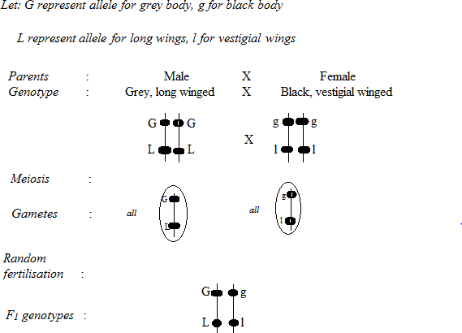

F1 phenotypes: all grey with long wings

Obtaining F2 generation:

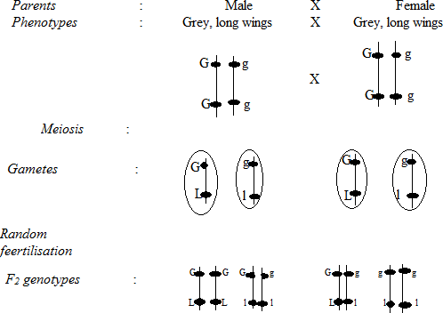

## Phenotypic ratio is 3 grey long winged: 1 black vestigial winged.

**Surprisingly,** the 3:1 ratio of parental phenotypes is never obtained in practice. This is because total linkage is rare. Instead approximately equal numbers of parental phenotypes are obtained with significantly few recombinant phenotypes also in approximately equal numbers.

**Definition:** Two or more genes are said to be linked if recombinant phenotypes occur much less frequently than parental phenotypes.

Total/complete linkage is when the distance between linked genes is not sufficient to allow for successful crossing over.

These results were explained by an *American scientist Thomas H. Morgan*. In a cross between a grey, long winged drosophila heterozygous for both traits with a black, vestigial winged drosophila (This is a test cross); Morgan predicted that in the normal Mendelian inheritance. Parental; phenotypes and recombinants would be obtained in a ratio of 1:1:1:1. If genes were completely linked, parental phenotypes would be obtained in a ratio of 1:1 **as shown below**.

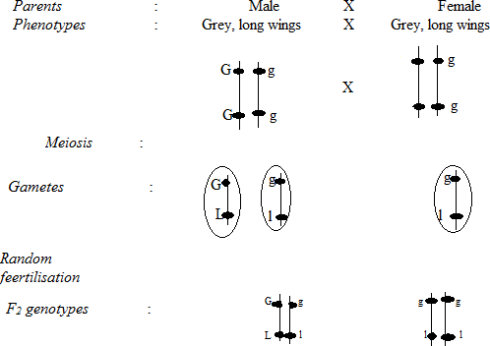

To his disappointment; even after performing the test cross several times, Morgan never obtained the predicted outcomes. He instead obtained approximately equal numbers of the parental phenotypes with significantly few recombinant phenotypes also in approximately equal numbers as summarized below.

41.5% grey, long winged

41.5% black, vestigial winged

8.5% grey, vestigial winged

8.5% black, long winged

Morgan explained his results in terms of crossing **over**; the responsive genes are located on the same chromosomes (linked) with the alleles of each gene on homologous chromosomes. Alleles were exchanged between homologous chromosomes during meiosis, leading to new gene combinations in gametes hence producing recombinant phenotypes; as shown below.

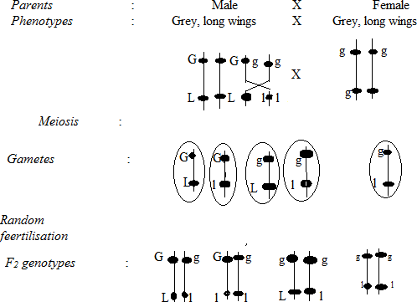

## Sample question:

A homozygous purple-flowered short stemmed plant was crossed with a homozygous red-flowered long stemmed plant and all the F1plants had purple flowers and short stems. When the F1generation was taken through a test cross, the following progeny was produced

53 purple flowered short stemmed 47 purple flowered long stemmed 49Red flowered short stemmed

45 red flowered long stems. Explain the results fully. **(Normal)**

## Crossing over and cross over values

During crossing over, the frequency of crossovers which take place was found to be dependent on the distribution and arrangement of chromosomes. This is given by the cross over value/frequency aka recombination frequency. This is calculated as a percentage ration of recombinants to the total number of offsprings.

𝐶𝑜𝑉 = 𝑁𝑢𝑚𝑏𝑒𝑟 𝑜𝑓 𝑟𝑒𝑐𝑜𝑚𝑏𝑖𝑛𝑎𝑛𝑡𝑠

𝑇𝑜𝑡𝑎𝑙 𝑛𝑢𝑚𝑏𝑒𝑟 𝑜𝑓 𝑜𝑓𝑓𝑠𝑝𝑟𝑖𝑛𝑔𝑠

𝑥100

## Example

In a test cross carried out on a grey long winged drosophila, the following results were obtained

|  |  |
| --- | --- |
| **Phenotype** | **Number of offsprings** |
| Grey, long winged | 965 |
| Black, vestigial winged | 944 |
| Black, long winged | 206 |
| Grey, vestigial winged | 185 |

## Solution:

𝐶𝑜𝑉 = 𝑁𝑢𝑚𝑏𝑒𝑟 𝑜𝑓 𝑟𝑒𝑐𝑜𝑚𝑏𝑖𝑛𝑎𝑛𝑡𝑠

𝑇𝑜𝑡𝑎𝑙 𝑛𝑢𝑚𝑏𝑒𝑟 𝑜𝑓 𝑜𝑓𝑓𝑠𝑝𝑟𝑖𝑛𝑔𝑠

𝑥100

𝐶𝑜𝑉 = 206 + 185

(965 + 944) + (206 + 185)

= 17%

The COV also indicates the **relative distance between** linked genes and the possibility of successful crossing over during meiosis, in the above case the distance between adjacent genes is 17 units. These values can also be used to position genes along the chromosome a process called **gene mapping**.

Consider the cross over values involving for different genes P, Q, R and S. The distance separating these four genes is shown below;

P-Q = 24% R-P = 14% R-S = 8% S-P = 6%

Draw the chromosome map to show the position of these chromosomes.

**Answer**. Draw the chromosome map for these genes

1. Insert the positions of the genes with the smallest cross over value first in the middle of the chromosome map
2. Examine the next largest cross over value and insert both possible positions of its genes on the chromosomes relative to either S or P.
3. Repeat the procedure for the entire remaining cross over values until you reach the largest cross over values.

## Example

In maize, the genes for coloured seed and full seed are dominant to the genes for colourless and shrunken seed. Pure breeding strains of double dominant variety were crossed with a double recessive variety and a test cross of the f1 generation produced the following results

|  |  |
| --- | --- |
| Coloured full | 380 |
| Colourless shrunken | 396 |
| Coloured shrunken | 14 |
| Colourless full | 10 |

Calculate the distance between the genes for coloured seed and seed shape

# DEGREES OF DOMINANCE

In the conventional Mendelian inheritance, each trait is controlled by a pair of alleles located at the same locus of homologous chromosomes, one dominant and the other recessive. In such cases, offsprings always resemble **one or the other of the parents** and phenotypes of the heterozygote and the dominant homozygote are indistinguishable. This condition is called **complete dominance.** Some traits however are controlled by alleles neither of which shows complete dominance or recessiveness over the other. Such alleles are either equally dominant (codominant) or incompletely dominant.

## INCOMPLETE DOMINANCE

This is when alleles fail to show complete dominance or recessiveness such that their phenotypes **blend (mix) to produce an intermediate** in the heterozygote.

When red snapdragons are crossed with white snapdragon plants (*Antirrhinum);* all the F1 hybrids have pink flowers, while F2 hybrids produced 1 red: 2pink:1white plants as shown below

Note: Given that both alleles of the same gene are dominant, we let a single letter for the gene and alleles attached as superscripts. I.e. CR and CW or simply R and W represent alleles for red and white petals respectively. The third phenotype results from flowers of the heterozygotes (CR CW or simply RW) having less red pigment than the red homozygotes.

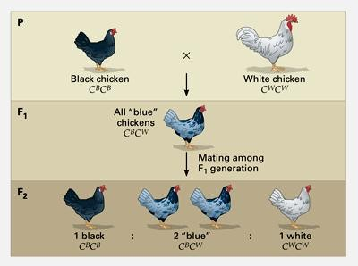

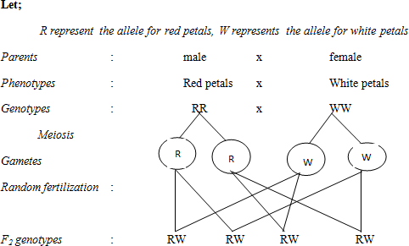

F1 phenotypes : All pink Obtaining F2

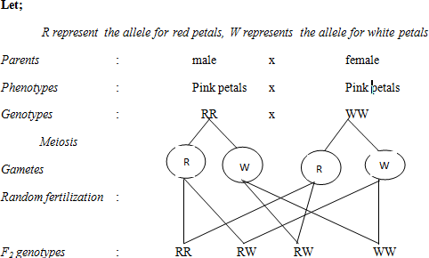

Genotypic ratios: 1RR: 2RW: 1WW Phenotypic ratios: 1 Red: 2pink: 1 White

Other examples of incomplete dominance include:

|  |  |  |
| --- | --- | --- |
| **Characteristic** | **Allelomorphic characteristics** | **Heterozygous phenotype** |
| Mirabilis Japalla  (4-oclock flower) | Red and White | Pink |
| Angora rabbit hair length | Long and short | Intermediate |
| Plumage colour in Andalusian fowls | Black and splashed white | Blue |

## CODOMINANCE

This is when alleles fail to show complete dominance or recessiveness such that their phenotypes are independently present in the heterozygote.

During the inheritance of fur/coat colour in short-horned cattle, when red and white cattle are mated, the F1 hybrid has white fur thickly interspersed with red fur. This phenotype is referred to as roan

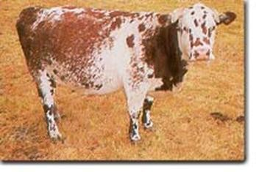

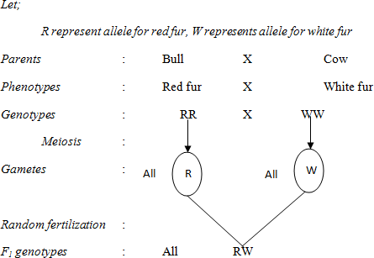

Other examples of codominance include ABO blood groups and Sickle-cell trait

## MULTIPLE ALLELES

These are three or more forms of the same gene occurring at the same locus

Most genes are known to occur in two alternative forms (allelic forms) located on the same locus of homologous chromosomes. Some genes are known to occur in more than two allelic forms called multiple alleles of which any two can occupy the gene locus in a diploid organism. This is easily noticed for the gene responsible for blood groups in man.

## INHERITANCE OF BLOOD GROUPS

The gene for human blood group is known to occur in three allelomorphic forms; A, B and o. Alleles A and B are codominant while o is recessive to both. This is known as the ABO blood grouping system, with three alleles producing six possible genotypes and four phenotypes.

|  |  |
| --- | --- |
| **Blood group** | **Possible genotypes** |
| A | Ao, AA |
| B | Bo, BB |
| AB | AB |
| O | Oo |

**Sample question**: The father and a mother are known to be heterozygous for blood groups A and B. Show the possible genotypes of their children. If they bear non-identical twins, what is the probability that both twins are of blood group A.

## Solution

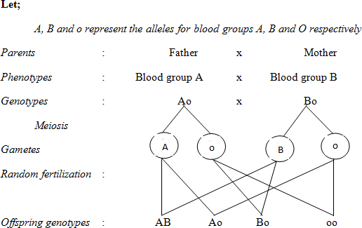

Offspring phenotypes: Blood groups AB, A, B and O Probability for a child with blood group A = ¼

Probability for both twins with blood group A = ¼ * ¼ =1/16 = 0.0625

## Example:

Work out the possible blood groups of the offsprings produced if a man of blood group A marries a woman of blood group AB

## THE RHESUS BLOOD GROUP SYSTEM

The rhesus blood group system is also inherited in a similar way to the ABO blood group system. Individuals with red blood cells with the D-antigens (Rhesus factor) are said to be rhesus positive (Rh+) while those without are called rhesus negative (Rh+). The allele for Rh+ allele is dominant over the one for rhesus negative (Rh-).

If a Rh+ man marries a Rh- woman, most of their children are likely to die immediately after birth or before birth because the mother’s immune system produces antibodies (anti-D agglutinins) which pass into the foetus and cause death. The first child usually survives because the time is too short for the mother to produce enough antibodies known as anti-D agglutinins which can pass to the foetus to cause death.

The problem may be solved in two major ways;

* 1. The mother may be injected with anti-D-agglutinins in the first 72 hours after her first born so as to make her immune system insensitive towards D-antigens.
  2. By carrying out proper intermarriages where by Rh+ man marries Rh+ woman and Rh- woman gets married to Rh- woman.

## ASSIGNMENT

1. Suppose a man having blood group A marries a woman who is heterozygous for blood group B what are the possible genotype and phenotypes.
2. A boy has blood group A and his sister has blood group B. what are the possible phenotypes and genotypes of their parents.
3. If a father has blood group A and the mother blood group AB what are the possible genotypes and phenotypes of the offspring.

# LETHAL GENES

Genes are usually known to control a single pair of contrasting traits. Some genes may affect more than one characteristics including mortality. Such genes are responsible for some features necessary for survival but they are simultaneously responsible for lethal effects in the organisms and are therefore called lethal genes.

An example is clearly illustrated in the inheritance of **fur colour in mice**. Wild mice are known to have grey coloured fur (a condition called agouti) or yellow fur. A cross between two yellow mice produces yellow and agouti offsprings in a ratio of **2: 1** respectively.

These results can be explained by the fact that allele for yellow fur is dominant over that for agouti and all living yellow mice are heterozygous for fur colour. The 2:1 ratio of phenotypes is due to the death of the yellow mice that are homozygous for fur colour before birth. This allele is therefore lethal in the homozygous condition.

The homozygous dominant mice die before birth producing a genotypic ratio of 2: 1 as the phenotypic ratio.

Examination of the uteri of yellow mice pregnant of yellow males revealed dead yellow mice; which are not revealed in yellow mice pregnant of agouti males.

## Note:

* The allele for yellow fur is dominant for fur colour but recessive for mortality. It can therefore persist within the population over generations in heterozygous genotypes without phenotypic exposure to environmental elimination.
* Dominant lethal genes are very rare in a population because they are phenotypically expressed for elimination by environment

## THE GENE COMPLEX

Many characteristics in plants and animals are produced by an interaction of several genes located on different loci; forming a gene complex. A single characteristic may be produced by the interaction of two or more genes occurring at different loci. A good example is shown by the inheritance of comb shape in domestic fowl

In this case, two genes on different chromosomes (loci) interact to produce four distinct phenotypes of combs. Pea and rose combs are each produced by presence of the dominant forms of their respective genes (P and R respectively) but in absence of the other dominant gene. The walnut and single combs are produced by the interaction of the genes at both loci as summarized below:

|  |  |  |
| --- | --- | --- |
| **Name of comb** | **Production** | **Possible genotypes** |
| Pea comb | Dominant allele P but without dominant allele R | PPrr, Pprr |
| Rose comb | Dominant allele R but without dominant allele P | ppRR, ppRr |
| Walnut comb | Dominant alleles for both P and R | PPRR, PpRR, PPRr, PpRr |
| Single comb | Only by homozygous double recessive condition | pprr |

Starting with pure breeding parents, the following are the expected results for F1 and F2 generations.

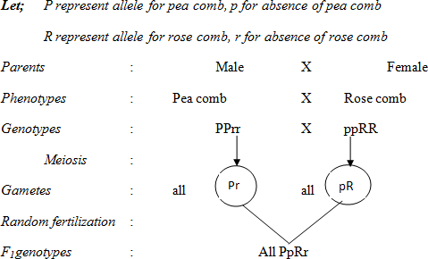

## All walnut combed

Obtaining F2

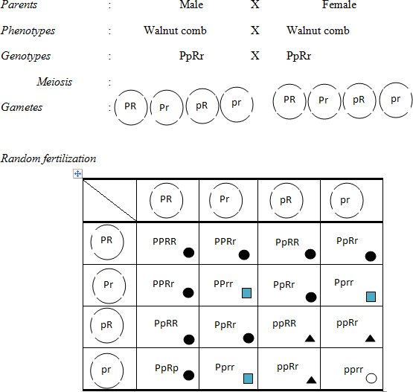

## Phenotypic ratios: 9 walnut: 3Pea: 3rose: 1single Sample

## Question

In poultry, the allele for white feathers (W) is dominant over the allele for black feathers (w). The alleles P, for pea comb and R, for rose comb produce their respective phenotypes. If they are present together, the comb shape is modified to walnut and if their recessive alleles are present in homozygous recessive condition, a single comb I produced. A cross between a black rose comb cock and a white walnut hen produced the following phenotypes:

3white walnut: 3black walnut: 3white rose: 3black rose: 1white pea: 1black pea: 1white single: 1black single. Identify the possible parental genotypes and show clearly how they give rise to the above phenotypes.

# EPISTASIS

This is a form of gene interaction where one gene suppresses the effects of another gene at a different locus. The suppressing gene is referred to as an **epistatic gene** (inhibiting gene) while the suppressed gene is called a **hypostatic** **gene**.

Fur color in mice depends on two **non-allelic genes**, the dominant form of one gene is responsible for coloured fur while its recessive form results into no colour deposition and the phenotype is white (albino). If colour is present, the nature is determined by another gene whose dominant allele produces grey fur (agouti) while the recessive allele produces black fur. Any of the two colours can be present only and only if their respective alleles are accompanied by the gene for coloured fur. Absence of this gene will result into albinos even if the genes for grey or white are present. The gene for coloured fur is hypostatic to the gene responsible for colour of fur (hypostatic).

This interaction produces three possible phenotypes as summerised below.

|  |  |
| --- | --- |
| **Phenotype** | **Possible genotypes** |
| Grey (agouti) | AAGG, AAGg, AaGG, AaGg |
| Black | AAgg, Aagg |
| Albino (white) | aaGG, aaGg, aagg |

## Examples

In oat plants, the inheritance of color is controlled by the gene with two alleles, the dominant results into colour formation while the recessive results into no colour formation (white or albino). The other gene is responsible for the kind of colour, if present with the allele for grey being recessive to one for black.

Identify the nature of gene interaction and show the F1 and F2 outcomes starting with true breeding parental stocks.

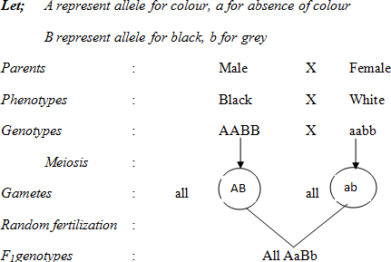

F1 phenotypes: All black Obtaining F2;

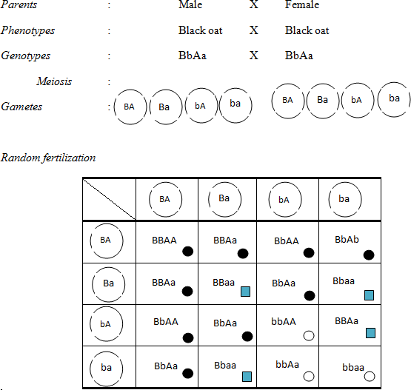

**INHERITANCE OF SEX AND SEX DETERMINATION**

In man, there are 23 pairs of chromosomes; of these only one pair carries genes for sex determination. These are called sex chromosomes (heterosomes) designated X and Y, and the other 22 pairs are called autosomes. A genotype XX is described as homogametic and is female while XY is described as heterogametic and is a male. During meiosis, the two sex chromosome segregate such that each ovum carries one X chromosome, half of the sperms carry an X chromosome and the other half carry a Y chromosome. If a sperm carrying an X chromosome fuses with the ovum, the zygote is female and if the sperm is carrying a Y chromosome, the zygote is male. Sex is therefore determined by the sex chromosome carried in the sperm as a matter of chance.

This is called the X-Y system and occurs mainly in mammals with humans inclusive. The females are described as homogametic because all their gametes contain the same sex chromosome-the X chromosome while the males are heterogametic because 50% of the gametes produced contain an X chromosome and 50% contain a Y chromosome for sex. In some animals like birds (including poultry), moths and butter flies; the sex genotypes are reversed. The homogametic genotypes (XX) are male while the heterogametic genotype (XY) is female.

In some cases, the Y chromosome is completely absent and the heterogametic sex (XO) is male. This is the X-O system as in grass hoppers, cockroaches and some insects. The sex of the offsprings is determined by whether the sperm cell contains an X chromosome or no sex chromosome. This implies that the Y chromosome does not carry genes needed for survival of the organisms.

In some species of bees and ants, there are no sex chromosomes. Females develop from fertilized eggs and are thus diploid while males develop from un fertilized eggs and are haploid, without feathers.

Example:

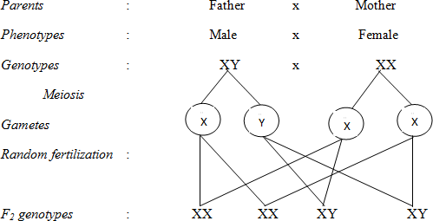

Genotypic ratios: 1XX: 1XY Phenotypic ratios: 1female: 1male

This shows that there is a 50% chance of any child being a male or female

## Environmental determination of sex

Sex is primarily genetically determined as described above but in some lower animals, sex can be determined by environmental factors such as temperature, salinity, type of food etc. for example in some turtles the eggs laid warm sand develop into females while those laid in cool sand develop into females.

## SEX CHROMOSOMES

The sex chromosomes are called heterosomes because they are non-identical and are designated X and Y. The X chromosome is rod shaped and much bigger than the Y chromosome which is hook shaped.

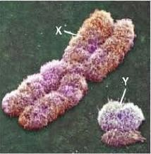

The Y chromosome carries genes responsible for secondary male sex characteristics, differentiation of testes and development of genital organs in humans. Actually in some organisms, the Y chromosome is absent and is believed not to carry genes necessary for survival of the organism and is described as genetically inert.

## SEX LINKAGE:

In humans, there are several thousands of characteristics each genetically controlled. With only 23 pairs of chromosomes, each chromosome must therefore carry many genes; a phenomenon that does not exclude sex chromosomes. These in addition to genes responsible for sex differences may carry genes determining some other features in the body.

Sex-linked genes are genes carried on sex chromosomes and inherited together with those determining sex. Sex linked traits (characters) are traits determined by genes carried on sex chromosomes and inherited together with those determining sex.

Note: The Y chromosomes don’t carry genes, sex linked genes are specifically carried on the X sex chromosomes but not on the Y chromosome.

Many experiments were carried out by Thomas Morgan about sex-linked genes in drosophila. In one of his experiment, Morgan mated a wild type (pure breeding) red-eyed female with a mutant (white eyed) male. All the F1 hybrids were red eyed. He went on to interbreed the F1 males and females to obtain an F2 generation which consisted of red eyed and white eyed offsprings in a ratio of 3:1 respectively. However, all female were red eyed and all the white eyed flies were males though some males were red eyed.

**In conclusion**, all the F1 were red eyed; implying that this allele is dominant over that for white. Since in the F2 all the white eyed were males, this indicates that the gene for eye colour is located on the X chromosome and there is no corresponding locus on the Y chromosome; otherwise some females would also be white eyed

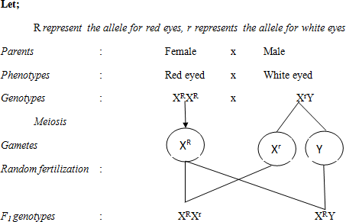

Obtaining F2 generation;

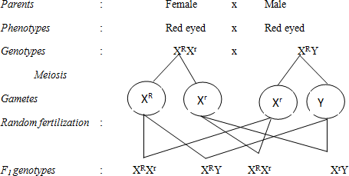

Phenotypic ratios: 3 red eyed: 1 white eyed

Note that all the white eyed are males yet some red eyed are males

## Sample question:

1. If the gene for eye colour was autosomal, predict the phenotypes of the F2 hybrids (including sex) in this hypothetical cross. (Show your working).
   1. Perform a test cross on the F1 female fly obtained in the above cross.
   2. What would be the phenotypes of the reciprocal cross between the original parents?
2. In drosophila, the genes for wing length and eye colour are sex-linked; with normal wings and red eyes being dominant to miniature wings and white eyes respectively.
   1. In a cross between a miniature-winged red eyed male and a homozygous normal wing white eyed female; explain the expected appearance of F1 and F2 generations.
   2. Crossing a female from the F1 generation above with a miniature wing white eyed male gave the following results:

|  |  |  |
| --- | --- | --- |
| Normal wing white eyed males and females | = | 35 |
| Normal wing red eyed males and females | = | 17 |
| Miniature wing red eyed males and females | = | 18 |
| Miniature wing white eyed males and females | = | 36 |

Account for the appearance and numbers of the phenotypes listed above.

## Examples of sex linked characters in man include the following

* + - Haemophilia
    - Colour blindness
    - Pre-mature balding
    - Eye colour in drosophila

Most of these characters are caused by recessive alleles and in a genetic cross, these must be represented as superscripts on the x sex chromosome.

## HAEMOPHILIA (BLEEDERS’ DISEASE)

Haemophilia is a recessive sex-linked blood disorder that leads to absence of one or more blood clotting factors, leading to prolonged bleeding even from minor cuts.

Just like other sex-linked traits, haemophilia is carried on the X chromosome and the responsive allele is recessive to the normal allele. The condition interferes with formation of blood clotting factors; commonly factor VIII (Anti- Haemophiliac Globulin) whose absence greatly delays the blood clotting process. This results into prolonged bleeding and excess blood loss even from minor cuts which may lead to death.

The allele being recessive, haemophiliac females must inherit two copies of the defective allele while males inherit one copy. The heterozygous females show normal blood clotting and are described as carriers. This is because the other X chromosome carries a dominant allele needed for normal blood clotting which suppresses the recessive allele for haemophilia. The males lack the alternative allele and the recessive allele is automatically expressed phenotypically.

**Example:** When a carrier woman is married to a normal man

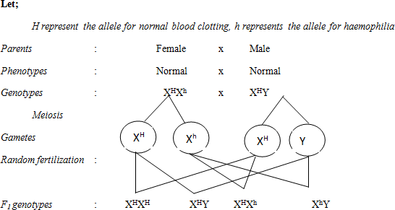

It can be noted that there is a 50% chance of a daughter being a carrier and a 50% chance of a son being haemophiliac. Sons can only inherit haemophilia (and other sex linked traits) from their mothers but not fathers as they only inherit the father’s Y chromosome and not the X chromosome that carries sex linked genes. Girls can inherit from both parents.

Today, people with hemophilia are treated as needed with intravenous injections of the missing protein.

## COLOUR BLINDNESS

It is a recessive sex linked character that leads to inability of the individual to distinguish between colours.

It is caused by a recessive allele, carried on the X chromosome and inherited in the same way as haemophilia. Colour vision is due to presence in the retina of red, blue and green cones needed for seeing the respective colours. The recessive alleles result into absence of some of these cones which renders inability to identify such colours from other related colours. This is called colour blindness; the commonest being red-green colour blindness where individuals lack red and green cones in their eyes.

## Example

Green colour blindness is sex linked in man. A normal man married a colour blind woman. Using suitable genetic symbols workout the genotypes and phenotypes of their children

Colour blind individuals **are more common** in the population than haemophiliacs despite the two being inherited in the same way. This is because haemophilia is associated with many lethal effects due to excessive internal and external bleeding which increases chance of dying before reproductive maturity to pass on their genes to the next generations. Colour blindness exerts less lethal effects as colour vision is not much necessary for survival. Colour blind individuals usually survive to reproductive age and pass the allele to subsequent generations hence increasing the number of colour blind individuals in the population. Also haemophiliacs are advised to desist from reproducing as they may end up bleeding to death which further reduces the numbers of haemophiliacs.

**NB:** Sex linked characters have been found to occur more commonly in males as compared to females in the human population. Being caused by recessive alleles, the other X chromosome in females may carry a dominant allele to mask the defective allele hence preventing its phenotypic expression in the population. In males however, these genes are carried on the non-homologous portion of the X chromosome for which there is no alternative gene on the Y chromosome. Such genes are automatically expressed in males leading to higher frequencies in males as compared to females.

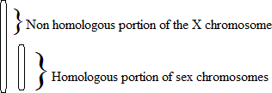

## SEX LIMITED CHARACTERISTICS

Se limited characters are characters that are more pronounced in one sex than the other.

Though both sexes may carry genes responsible for these characteristics, pronounced expression is strictly limited to one of the two sexes. They are usually carried on autosomes but may largely be influenced by the level of sex hormone in the body.

## Examples include;

Facial hair, deep voice, baldness etc in males

Breasts, lactation, widening of hip bones, high pitched sound etc

## PEDIGREE ANALYSIS

Whereas peas are convenient subjects for genetic research, humans are not. The human generation span is about 20 years, and human parents produce relatively few offspring compared to peas and most other species. Even more important, no one would consider it ethical to ask pairs of humans to breed so that the phenotypes of their offspring could be analyzed! In spite of these constraints, the study of human genetics continues to advance, spurred on by the desire to understand our own inheritance. New techniques in molecular biology have led to many breakthrough discoveries, as we will see in Chapter 20, but basic Mendelism endures as the foundation of human genetics .Unable to manipulate the mating patterns of people, geneticists must analyze the results of matings that have already occurred. They do so by collecting information about a family's history for a particular trait and assembling this information into a family tree describing the traits of parents and children across the generations-the family pedigree. Figure 14.1Sa shows a three- generation pedigree that traces the occurrence of a pointed contour of the hairline on the forehead. This trait, called a widow's peak, is due to a dominant allele, W because the widow's peak allele is dominant; individuals who lack a widow's peak must be homozygous recessive *(ww).* The two grandparents with widow's peaks must have the *Ww* genotype, since some of their offspring are homozygous recessive. The offspring in the second generation who *do* have widow's peaks must also be heterozygous, because they are the products of *Ww* x *ww* matings. The third generation in this pedigree consists of two sisters. The one who has a widow's peak could be either homozygous (WW) or heterozygous *(Ww),* given what we know about the genotypes of her parents (both *Ww).* Figure 14.1Sb is a pedigree of the same family, but this time we focus on a recessive trait, attached earlobes. We'll use *f* for the recessive allele and *F* for the dominant allele, which results in free earlobes. As you work your way through the pedigree, notice once again that you can apply what you have learned about Mendelian inheritance to understand the genotypes shown for the family members.

An important application of a pedigree is to help us calculate the probability that a child will have a particular genotype and phenotype. Suppose that the couple represented in the second generation of Figure 14.15 decides to have one more child. What is the probability that the child will have a widow's peak? This is equivalent to a Mendelian F] monohybrid cross *(Ww* x *Ww),* and thus the probability that a child will inherit a dominant allele and have a widow's peak is ¾ (¼ WW + ½ Ww). What is the probability that the child will have attached earlobes? Again, we can treat this as a monohybrid cross *(Ff* x *Ff),* but this time we want to know the chance that the offspring will be homozygous recessive *(.ff).* That probability is ¼ . Finally, what is the chance that the child will have a widow's peak *and* attached earlobes? Assuming that the genes for these two characters are on different chromosomes, the two pairs of alleles will assort independently in this dihybrid cross *(WwFf* x *WwFf).* Thus, we can use the multiplication rule: ¾ (chance of widow's peak) x ¼ (chance of attached earlobes) = 3/16 (chance of widow's peak and attached earlobes).

Pedigrees are a more serious matter when the alleles in question cause disabling or deadly diseases instead of innocuous human variations such as hairline or earlobe configuration. However, for disorders inherited as simple Mendelian traits, the same techniques of pedigree analysis apply.

## QUESTIONS

I. Beth and Tom each have a sibling with cystic fibrosis, but neither Beth nor Tom nor any of their parents have the disease. Calculate the probability that if this couple has a child, the child will have cystic fibrosis.

What would be the probability if a test revealed that Tom is a carrier but Beth is not?

1. Joan was born with six toes on each foot, a dominant trait called polydactyly. Two of her five siblings and her mother, but not her father, also has extra digits. What is Joan's genotype for the number-of-digit character? Explain your answer. Use D and *d* to symbolize the alleles for this character.
2. What would you suspect if Peter was born with polydactyly, but neither of his biological parents had extra digits?
3. *Incomplete dominance* and *epistasis* are both terms that define genetic relationships. What is the most basic distinction between these terms?
4. If a man with type AB blood marries a woman with type 0 blood, what blood types would you expect in their children?
5. A rooster with gray feathers is mated with a hen of the same phenotype. Among their offspring, 15 chicks are gray, 6 are black, and 8 are white. What is the simplest explanation for the inheritance of these colors in chickens? What phenotypes would you expect in the offspring of a cross between a gray rooster and a black hen?

1. A white-eyed female *Drosophila* is mated with a red eyed (wild-type) male, the reciprocal cross of the one shown in Figure 15.4. What phenotypes and genotypes do you predict for the offspring?

3. Genes *A, B,* and C are located on the same chromosome. Testcrosses show that the recombination frequency between A and *B* is 28% and between A and C is 12%. Can you determine the linear order of these genes? Explain.

**VARIATION**

Variation describes the differences in characteristics shown by organisms belonging to the same natural population or species

**TYPES OF VARIATION**

There are two basic forms of variation that occur in any large population basing on the phenotypic differences i.e. discontinuous and continuous variation.

**Discontinuous variation**

This is s a type of variation in which certain characteristics with in a population exhibit a limited form of difference. This produces individuals showing clear – cut differences with no intermediates between them.

Examples

-blood groups in humans, wing length in drosophila, melanic and light forms in *Biston betularia*, style length in *primula*, sex in animals and plants, tongue rolling, albinism.

Characteristics showing discontinuous variation are usually controlled by one or two genes which may have two or more allelic forms and their phenotypic expression is relatively unaffected by environmental conditions.

Discontinuous variation is also qualitative inheritance because the phenotypic variation is restricted to certain clear – cut characteristics.

**Continuous variation**

This is where certain characteristics with in a population vary only very marginally between one individual and the next. This results in a gradation from one extreme to the other.

Examples

Mass, linear dimension, shape and colour of organs and organisms, etc.

Characteristics exhibiting continuous variation are produced by the combined effects of many genes (polygenes) and environment factors.

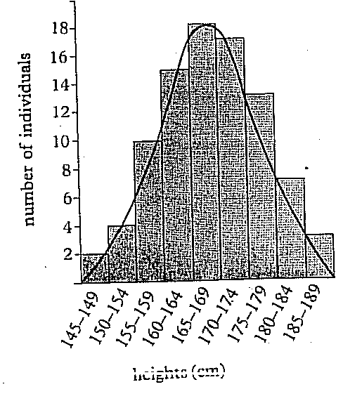

**ORIGIN /SOURCES OF VARIATION**

The core factors determining a phenotypic characteristic of an organism is the **genotype**. But the subsequent degree of expression allowed to tis genetic potential is influenced by the action of environmental factors during the development of the organism e.g. adequate light, temperature, water and soil conditions. Thus both genotypic/gene reshuffles and environmental factors interact to cause an effect on the phenotype.

**Environmental factors**

If organisms of identical genotypes are subjected to different environmental influences, they show variety. This is because environmental influences are various and often form gradations. They are responsible for continuous variation with in a population.

**Reshuffling of genes**

The sexual process in organisms has three method of causing variety.

* Crossing over; the reciprocal crossing over of genes between chromatids of homologous chromosomes may occur during prophase I of meiosis. This produces new linkage groups and so provides a major source of genetic recombination of alleles.
* Independent assortment; the orientation of the chromatids of homologous chromosomes (bivalents) on the equatorial spindle during metaphase I of meiosis determines the direction in which the pairs of chromatids move during anaphase I. this orientation of chromatids is random. During metaphase II, the orientation of pairs of chromatids once more is random, and determines which chromosomes migrate to opposite poles of the cell during anaphase II. These random orientations and the subsequent independent assortment (segregation) of the chromosomes give rise to a large number of different chromosome combinations in the gametes.
* Random fusion of gametes; during sexual reproduction, the fusion of male and female is completely random. Thus, any male gamete is potentially capable of fusing with any female gamete. This causes variation.

However, these sources of variation do not generate the major changes in genotype which are necessary in order to give rise to new species as described by evolutionary theory. These changes are produced by mutations.

**MUTATIONS**

These are changes in the amount, arrangement or structure of DNA of an organism.

These produce changes in the genotype which may be inherited by cells derived by mitosis or meiosis from the mutant cell.

Most mutations occur in somatic cells and are not passed from one generation to the next. Only those mutations which occur in the formation of gametes can be inherited. These mutations are the basis of discontinuous variation. Mutations on body cells are called **somatic mutations**.

**TYPES OF MUTATIONS**

There are two types of mutations i.e. point/gene mutation and chromosomal mutations/ aberrations.

**Gene mutations**

These describe the changes in the structure of DNA at a single locus on a chromosome. These cause the wrong arrangement of nucleotides on the DNA molecule leading to formation of wrong sequence of amino acids in the protein it makes.

This protein (enzyme) may have a different molecular shape hence unable to catalyze its reaction, and can’t form end products of such reactions.

These cause profound effects in organisms e.g. a gene mutation resulting in the absence of pigments such as melanin, leading to albinism, cystic fibrosis and Huntington’s disease.

There are many forms of gene mutations

* **Duplication**: a portion of a nucleotide chain becomes repeated.
* **Addition**/insertion: an extra nucleotide sequence becomes inserted in the chain.
* **Deletion**: a portion of the nucleotide chain is removed from the sequence.
* **Inversion**: a nucleotide sequence becomes separated from the chain. It rejoins in its original position only inverted. The nucleotide sequence of this portion is therefore reversed.
* **Substitution**: one of the nucleotides is replaced by another which has a different organic base.

**Chromosomal mutations**

These result from a change in the amount or arrangement or structure of DNA.

1. **Changes in whole set of chromosomes**

There are two changes that occur to bring about chromosomal mutations i.e. aneuploidy and euploidy (polyploidy)

**Aneuploidy**

These are changes which involve the loss or gain of single chromosomes.

This causes formation of daughter cells, half having extra chromosomes (n + 1), (2n+1) and so on, whilst the other half having a chromosomes missing (n-1), (2n-1) and so on.

Aneuploidy arises from the failure of a pair or pairs of homologous chromosomes to separate during anaphase I of meiosis, a process called **non – disjunction**. If this occurs, both sets of chromosomes pass to the same pole of the cell and separation of the homologous chromosomes during anaphase II leads to formation of gamete cells containing either one or more chromosomes, too many or too few. Fusion of either of these gametes with a normal haploid gamete produces a zygote with an odd number of chromosomes.

Zygotes with less than the diploid number of chromosomes usually fail to develop, but those with extra chromosomes develop.

Aneuploidy in animals causes abnormalities e.g. in humans chromosomal mutation resulting from non – disjunction is a form of **trisomy** called **Down’s syndrome** (2n = 47).

Non – disjunction of sex chromosomes can also occur e.g. **Klinefelter’s** syndrome with XXY, XXXY or XXXXY genotypes. These individuals appear male but have small testes and no sperm in the ejaculate, **Turner’s** syndrome have one missing X chromosome hence XO genotype. These individuals are aborted but those who survive are phenotypically females but small in stature and sexually immature.

**Euploidy (polyploidy)**

This is where gametes and somatic cells contain multiples of the haploid number of chromosomes.

When three sets (3n) of chromosomes are present, the organism is triploid, with four sets (4n), it is tetraploid.

Polyploidy is much more common in plants than in animals e.g. most species of angiosperms are polyploidy. It is rare in animals because increased number of chromosomes in polyploidy makes normal gametes formation during meiosis more prone to error. But plants are capable of propagating themselves vegetatively, they are able to reproduce despite being polyploidy.

Polyploidy is associated with advantageous features such as increased size, hardness and resistance to diseases. This is called **hybrid vigor**. Most domestic plants are polyploids producing large fruits, storage organs, flowers and leaves.

There are two forms of polyploidy; autopolyploidy and allopolyploidy.

* **Autopolyploidy**: This is a polyploidy in which the increases in sets of chromosomes occurs naturally or artificially with in the same species. The actual number of chromosomes in an autopolyploid is usually an exact multiple of its haploid numbers. Autopolyploidy can be induced by a chemical called **colchicine** from corms. Colchicine inhibits spindle formation and so prevents chromosomes separating during anaphase.
* **Allopolyploidy**: This condition arises when the chromosome number in a sterile hybrid becomes doubled and produces fertile hybrids. The F1 hybrids produced from different species are sterile since their chromosomes cannot form homologous pairs during meiosis, a process called **hybrid sterility**.

1. **Changes in chromosome structure**

There are four mays or mutations that cause changes in the structure of the chromosome namely

* **Deletion**: a portion of a chromosome is lost
* **Inversion**: a portion of the chromosome becomes deleted but becomes reattached in an inverted position.
* **Translocation**: a portion of the chromosome becomes deleted and rejoins at a different point on the same chromosome or with a different chromosome.
* **Duplication**: a portion of the chromosome is doubled resulting in repetition of a gene sequence.

**CAUSE OF MUTATIONS**

The natural mutation rates can be increased artificially by certain chemicals or energy sources. Any agent of which induces mutations is called a **mutagen** and the resulting individual is a **mutant**.

They include

* High energy radiations like UV light, X – rays and gamma rays.
* High energy particles such as alpha and beta particles, and neutrons, cosmic radiations, etc.
* Chemicals like colchicine, formaldehyde, nitrous acid and mustard gas, caffeine, drugs, pesticides and food preservatives.

**IMPLICATIONS OF MUTATION**

* Many cases of mutations are lethal and prevent development of the organism.
* Some chromosome mutations bring certain gene sequences together, causing beneficial characteristics.
* Gene mutations may lead to several alleles occupying a specific locus, this increases both the heterozygosity and size of the gene pool of the population, leading to increased variation within a population.
* Gene reshuffling as a result of crossing over, independent assortment, random fertilization and mutations may increase the number of continuous variation, though evolutionary implications may be short-lived since the change produced are rapidly diluted.
* Some gene mutations may increase discontinuous variation which has profound effect on changes in the population.
* Most gene mutations being recessive to the normal allele, this forms genetic equilibrium with the rest of the genotype and the environment as a result of withstanding selection over many generations.